Assignment 6

Q1. Configure DNS Services with a Server.
1. Open the DNS Server and go to Services → DNS.
2. Turn the DNS service On.
3. Add an A Record with the following details:
- Name: swapnaraj.com
- Address: 192.168.10.10
- Click Add to save the DNS record.

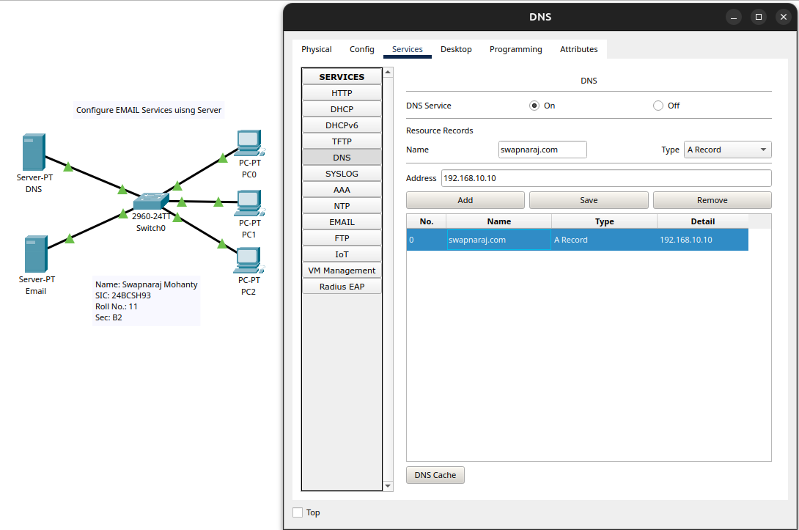

Q2. Configure EMAIL Services with a Server.
1. Open the Email Server and go to Services → EMAIL.
2. Turn the SMTP Service and POP3 Service On.
3. Enter swapnaraj.com as the Domain Name and click Set.
4. Create the email user accounts:
- Username: user1, Password: user1
- Additional users: user2 and user3

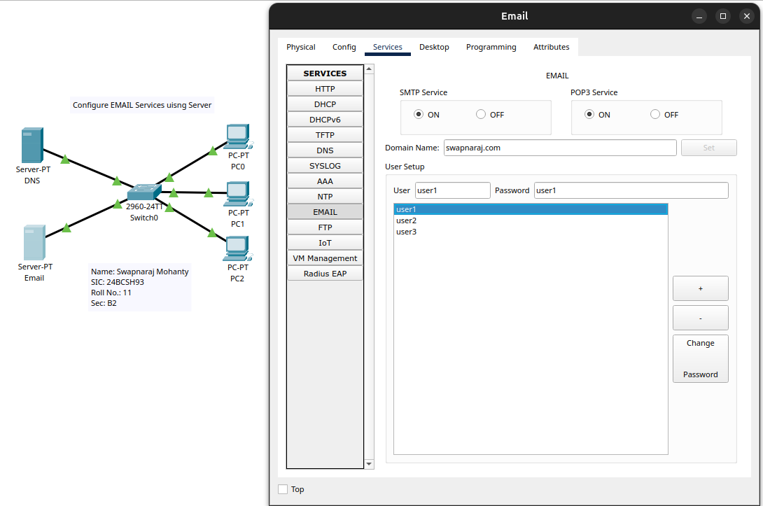

Q3. Send and Receive an Email.
1. On PC0, open Desktop → Email and compose a new message.
2. Enter the following details:
- To: user1@swapnaraj.com
- Subject: Cisco Packet Tracer
- Message: Name, SIC, and Roll No.
3. Click Send to send the email.
4. On PC1, open Desktop → Email and click Receive.
5. Verify that the email appears in the inbox and open it to view the message.



